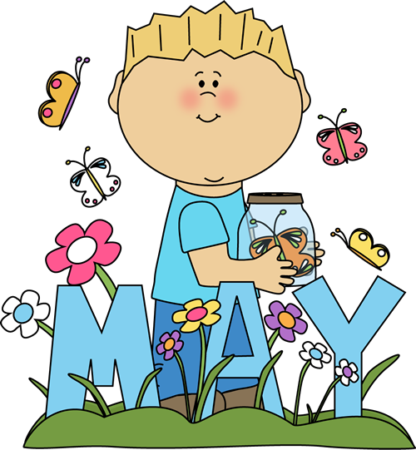
MVRA Community Supports
GROUP C
ACTIVITIES CALENDAR 2017
^{MONDAY} | ^{TUESDAY} | ^{WEDNESDAY} | ^{THURSDAY} | ^{FRIDAY}
^{1st}  ^{1. Open social time 11a-11:30a}  2. Bring your own lunch -11:30a-12p  3. 12p-1pSpecial Olympic Meeting  4.1p-4p Special Olympic Training  ^{5. 4p-4:45p Social time}  6 .Prepare to leave 4:45p and leave at 5p.  ^{Scheduled hours 11a-5p} | ^{2nd}  ^{1.Social time 9a-9:15a}  2.Free Movie Day - (Apollo 13) 9:15a-12p  3.Lunch/bring your own in- 12p-12:30p  ^{4. Social time 12:30-12:45p}  5. Prepare to leave 12:45p and leave at 1p  -$3.00 if you want popcorn /soda  ^{Scheduled hours 9a-1p} | ^{3rd}  ^{1. Open social time 11a-11:30a}  2. 11:30a-12p Bring your own lunch  3. 12p-1:30p Hiking in Vaughans Woods (hobbit land)  1:30p-2:45p Tour Hallowell shops  5. Prepare to leave 2:45p and leave at 3p.  ^{Scheduled hours 11a-3p} | ^{4th}  ^{1. Open social time 11a-11:30a}  2. 11:30a-12p Bring your own lunch  3. 12p-1p Coffee Social and work on 1st & 2nd week of Junes calendar  ^{1p-2:45p Outside sports games}  5. Prepare to leave 2:45p and leave at 3p.  ^{Scheduled hours 11a-3p} | ^{5th}  ^{1. Open social time 11a-11:30a}  2. 11:30a-12p Bring your own lunch  ^{3. 12p-2:45p YMCA Swimming Day}  4. Prepare to leave 2:45p and leave at 3p.  ^{Bring in suit and towel}  ^{Scheduled hours 11a-3p}
^{8th}  ^{1. Open social time 11a-11:30a}  2. Bring your own lunch -11:30a-12p  3. 12p-1pSpecial Olympic Meeting  4.1p-4p Special Olympic Training  ^{5. 4p-4:45p Social time}  6 .Prepare to leave 4:45p and leave at 5p.  ^{Scheduled hours 11a-5p} | ^{9th}  ^{1.Social time 9a-9:15a}  2.Free Movie Day - (North to Alaska) 9:15a-12p  3.Lunch/bring your own in- 12p-12:30p  ^{4. Social time 12:30-12:45p}  5. Prepare to leave 12:45p and leave at 1p  ^{Scheduled hours 9a-1p} | ^{10th}  Special Olympic Regional’s in Farmingdale at Hall Dall High School  ^{Scheduled Hours 7:30am-3pm} | ^{11th}  ^{1. Open social time 11a-11:30a}  2. 11:30a-12p Bring your own lunch  3. 12p-2;45p Fishing at local lake-bring your fishing equipment if you want to.  4. Prepare to leave 2:45p and leave at 3p.  ^{Scheduled hours 11a-3p} | ^{12th}  ^{1. Open social time 11a-11:30a}  2. 11:30a-12p Bring your own lunch  ^{3. 12p-2:45p Frisbee Golf}  5. Prepare to leave 2:45p and leave at 3p.  ^{Scheduled hours 11a-3p}
^{15th}  ^{1. Open social time 11a-11:30a}  2. Bring your own lunch -11:30a-12p  3. 12p-1pSpecial Olympic Meeting  4.1p-4p Special Olympic Training  ^{5. 4p-4:45p Social time}  6 .Prepare to leave 4:45p and leave at 5p.  ^{Scheduled hours 11a-5p} | ^{16th}  ^{1.Social time 9a-9:15a}  2.Free Movie Day - (Silver Streak) 9:15a-12p  3.Lunch/bring your own in- 12p-12:30p  ^{4. Social time 12:30-12:45p}  5. Prepare to leave 12:45p and leave at 1p  ^{Scheduled hours 9a-1p} | ^{17th}  ^{1. Open social time 11a-11:30a}  2. 11:30a-12p Bring your own lunch  3. 12p-2:45p Mini Golf and ice cream social  5. Prepare to leave 2:45p and leave at 3p.  ^{Scheduled hours 11a-3p} | ^{18th}  ^{1. Open social time 11a-11:30a}  2. 11:30a-12p Bring your own lunch  3. 12p-1p Coffee Social and work on 3rd & 4th week of Junes calendar  ^{1p-2:45p Outside tennis}  5. Prepare to leave 2:45p and leave at 3p.  ^{Scheduled hours 11a-3p} | ^{19th}  ^{1. Open social time 11a-11:30a}  2. 11:30a-12p Bring your own lunch  3. 12p-2:45p Outside basket Ball game  5. Prepare to leave 2:45p and leave at 3p.  ^{Scheduled hours 11a-3p}
^{22nd}  ^{1.Social time 9a-9:30a}  2. 9:30a-2p Maine Wild Life Park in Gray Maine  ^{3. 2p-2:45p social time.}  4. Prepare to leave 2:45p and leave at 3pm.  ^{$8.00}  Must bring a cold picnic lunch.  ^{Scheduled Change}  ^{9a-3pScheduled hours 11a-5p} | ^{23rd}  ^{1.Social time 9a-9:15a}  2.Free Movie Day - (Sixteen Candles) 9:15a-12p  3.Lunch/bring your own in- 12p-12:30p  ^{4. Social time 12:30-12:45p}  5. Prepare to leave 12:45p and leave at 1p  ^{Scheduled hours 9a-1p} | ^{24th}  ^{1. Open social time 11a-11:30a}  2. 11:30a-12p Bring your own lunch  3. 12p-2:45p Special Olympic Training  5. Prepare to leave 2:45p and leave at 3p.  ^{Scheduled hours 11a-3p} | ^{25th}  ^{1. Open social time 11a-11:30a}  2. 11:30a-12p Bring your own lunch  3. 12p-2;45p Fishing at local lake-bring your fishing equipment if you want to.  4. Prepare to leave 2:45p and leave at 3p.  ^{Scheduled hours 11a-3p} | ^{26th}  ^{1. Open social time 11a-11:30a}  2. 11:30a-12p Bring your own lunch  ^{3. 12p-2:45p YMCA Swimming Day}  4. Prepare to leave 2:45p and leave at 3p.  ^{Bring in suit and towel}  ^{Scheduled hours 11a-3p}
^{29th}  ^{NO PROGRAM}  ^{ENJOY MEMORIAL DAY} | ^{30th}  ^{1.Social time 9a-9:15a}  2.Free Movie Day - (Mister Roberts) 9:15a-12p  3.Lunch/bring your own in- 12p-12:30p  ^{4. Social time 12:30-12:45p}  5. Prepare to leave 12:45p and leave at 1p  ^{Scheduled hours 9a-1p} | ^{31st}  ^{1. Open social time 11a-11:30a}  2. 11:30a-12p 1st BBQ of the year Do not bring a lunch  3. 12p-2:45p Making tye dye T-shirts for Special Olympics outside  5. Prepare to leave 2:45p and leave at 3p  ^{Scheduled hours 11a-3p} | ^{1st}  1. Open social time 11a-12p Bring your own lunch  2. 12p-1p Finish making tye dye T-shirts for Special Olympics  ^{3 1p-2:45p Driving golf Range}  4. Prepare to leave 2:45p and leave at 3p.  ^{Scheduled hours-11a-3p} | ^{2nd}  ^{1. Open social time 11a-11:30a}  2. 11:30a-12p Bring your own lunch  3.12p-1p Tour Waterville Trains  ^{4. 1p-2:45p TJ’s Pool Hall}  5. Prepare to leave 2:45p and leave at 3p.  ^{Scheduled hours 11a-3p}

